**IBTIKAAR NURSERY**

**All About Us**

**-------------------------------------------------------------------------------------------------------------------------------------------------------------**

**Introduction**

Thank you for choosing Ibtikaar nursery to start your child's journey. Ibtikaar is a day care nursery where we provide care and education for children aged from 1 year 6 months to 5 years. We offer private places as well as funded (15 / 30 hours a week session). We aim to provide the highest standards of care and learning for your children.

**Sessions**

We operate during term time and have a holiday club. The nursery is open Monday to Friday from 8:30 to 3:30.

|  |
| --- |
| 1 hour rate = £7 |

* **Out fees structure are:**

**Nursery staff**

All staff at Ibtikaar nursery has been checked through the Criminal Records Bureau. The majority of the staff holds a level 3 or above qualification in childcare. There is always a designated safeguarding leader (DSL) on site. Also most of the staff holds a qualification in first aid paediatric training. To develop our CPD our staff are trained by outside agencies and also receive regular in-house trainings.

**Our believes**

We believe that all children are entitled to the best possible start in their life, both intellectually and emotionally, in order to enable them to develop their full potential. We aim to support each child’s welfare, learning and developmental needs. We also recognise that all children are unique and special and that they develop in individual ways and at varying rates. We aim to provide a safe, secure and caring environment where children feel happy and know that they are valued by the practitioners looking after them. We want to educate children to integrate successfully into the British Society. At Ibtikaar nursery we actively promote the British Values.

**Safeguarding**

We are required to follow procedures as laid down by the **"Children Advise and Support Services" (CASS)** in place to safeguard all children from abuse and harm. The designated safeguarding leader (DSL) for Ibtikaar nursery is the manager. In her absence you can speak to Deputy manage. The role of the DSL is to provide support, advice and guidance to practitioners and parents/carers on an on-going basis, and deal with any specific safeguarding issues as and when required.

**Mobile phones**

We have a strict no mobile phone policy inside the nursery. When practitioners come to the nursery they are required to switch off their phones and put them away in a box in the office. We would appreciate if parents and carers could avoid using their mobile phones when inside the nursery.

**Security**

Security has been a focus for the design and building of our nursery and it’s outside play area. We main doors locks automatically and can only be opened by practitioners. We have strict procedures in place for any visitors where we ask for I.D and always get them to sign into the visitor’s book. Visitors are NEVER left unsupervised with children and are always escorted out of the building.

**Fire procedure**

We practice fire drills with the children on a regular basis. The fire exits are marked clearly and are always kept clear. The assembly point for Ibtikaar nursery is the bus stop outside the nursery.

# **Parents as Partners**

We value the role of parents/carers as children’s primary educators and we recognise the importance of establishing positive relationships with parents. We understand that an effective partnership between the nursery and home will have a positive impact on child’s learning and progress. Therefore practitioners are encouraged to regularly share information with parents/carers. Parents are kept informed of what is happening in the nursery through regular newsletters, workshops, parent evenings, children’s’ feedback forms and informal chatting at the beginning and end of the day. Parents/carers are invited to attend parents’ evenings at the end of each term. Parents/carers are also invited to get involved with nursery-life. The setting has a friendly, open-doors policy and parents/carers are encouraged to discuss any concerns they might have with the manager

**Clothing, nappies and belongings**

* Please ensure you clearly label all your children's clothes and belongings
* Please don't send your child's clothes or belongings in a plastic bag as they can be hazardous for children
* Please provide a change of clothing for your child in case of accidents, water play or messy play
* We recommend your child wears old or easily washable clothes. Although we provide aprons, children may still get wet or messy when exploring and having fun
* Please ensure you provide us with a supply of nappies and wipes
* Please provide your child with wellingtons to change into for outdoor activities

**Illness**

Please keep your child at home if they are unwell. We would request parents/carers to notify the nursery if their child will be absent from the nursery. Children must be kept away from the nursery for at least **48 hours** after the last case of diarrhoea and/or vomiting has stopped. We will contact you to collect your child if they become unwell at nursery. Children who are unwell and have a temperature must be kept at home. We follow department of Health guidelines on exclusion for infectious or contagious illness. You are welcome to speak to management for further advice or information.

**Medicine**

We require written consent to administrate any medication. We cannot administrate any medicine unless they have been prescribed by your child's doctor. If your child is on antibiotics they will need to have taken it for 48 hours before returning to the nursery. Please ensure you inform the nursery if your child has any medical needs such allergies or asthma. You will need to provide the setting with an inhaler or the medication in case of an emergency.

**Special Needs**

The nursery has 1 special education needs co-ordinators (SENCO). The SECNO at Ibtikaar is Shaheen Akhtar. Children who have special needs are welcomed at Ibtikaar nursery. We aim to liaise with parents and other professional’s to ensure that the children’s individual needs are met, and that they are able to develop in all areas of learning.

**Equal Opportunities**

We believe that no child, individual or family should be excluded from the nursery on the grounds of age, gender, sexuality, class, family status, ability, colour, ethnic origin, culture, religion or belief. We aim to provide the best opportunity for children to reach their full potential and we will help children to develop a positive self-image. Our equal opportunities policy applies to all the children, families, staff, volunteers and visitors at Ibtikaar Nursery.

**Collection of your child**

Parents/carers must inform the nursery if they need to drop their child or collect them later then the agreed time, in order to ensure that staff ratios are maintained. If someone other than yourself will be collecting your child you must inform management. Their details must be recorded on the application form and they must be also able to provide the setting with the correct password. Your child will not be allowed to leave alone with anyone who is under the age of 18.

**Behaviour management**

We have a behaviour management policy in place, which parents and carers are welcome to read. At Ibtikaar nursery we encourage children to learn and share with others. We aim to provide clear rules and boundaries for the children. Any unwanted behaviour is managed in a fair and consistent manner. When dealing with negative behaviour we will always communicate in a clear, calm and positive manner. If you ever have any concerns around your child’s behaviour we are always available to discuss this with you. Positive behaviour will be reinforced with praise and encouragement.

**Policies and procedures**

All of our nursery policies and procedures are available for parents and carers to read and are located in the entrance on the table. Please speak to the management team if you would like to receive a copy.

**The settling in process**

We have a set procedure for settling children. However this can be adapted to meet the child’s individual needs.

**Session 1**:

This visit will be **1 hour**; parents/carers must stay with their child and take them home after an hour

**Session 2/3:**

On the second and third visit parent/carers are asked to stay with their child for half an hour and then leave their child alone for an hour

**By session 4:**

The child may be starting to show signs of independence and the child can be left alone for longer periods. We consider a child settled when they have formed a relationship with their key worker and participants in key activities. When you leave your child we ask that you say goodbye and clearly explain to them that you will be coming back later.

**Key worker system**

Your child will have a special Key person to meet their individual needs. A key worker is someone who is responsible for a small group of children. They will be dedicated to support each child’s, physical, emotional, learning and development needs on a day to day basis. They will work closely with the child’s parent/ carer to make the child feel safe and secure. The key worker will also complete a learning journal for each individual child.

**The EYFS Framework**

At Ibtikaar nursery we use the Early Years Foundation Stage (EYFS) Development Matters Framework, which is a guidance tool for professional’s to use to support your child in their leaning and development. The EYFS is used to observe and assess what and how your child is learning and plan activities that will help develop them further. The EYFS has 7 areas of learning, and are divided into prime and specific areas. Prime areas are important as they build a foundation for your child to develop their learning in the specific areas, in preparation for school.

**As each child is unique, these are implemented throughout the day via play:**

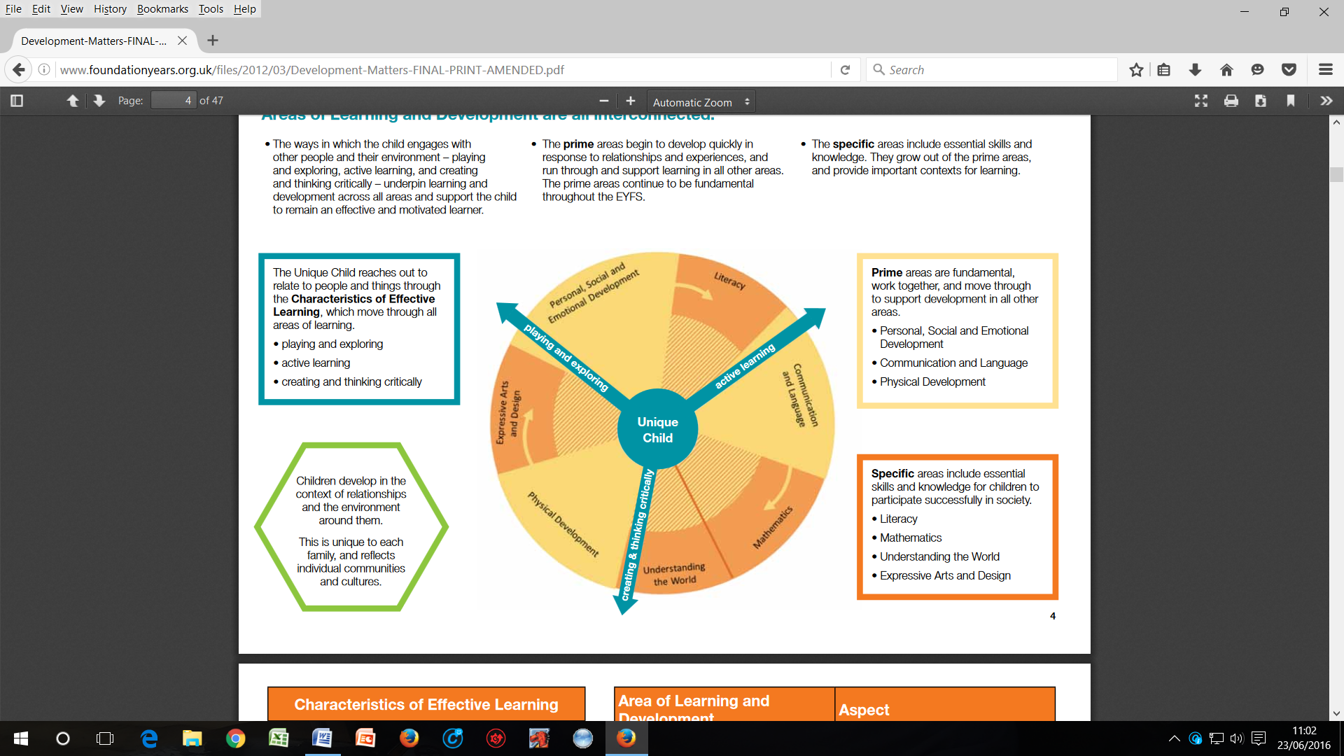

**2 Year old Progress Check Summary**

The progress check at age 2 is a requirement of the Early Years Foundation Stage. The progress check at age two is different to the NHS health check (sometimes called a development review) and both checks are important. Please make sure that you take your child to their health check, if you are invited to one.

**The aims of the progress check at age two are to:**

* Review your child’s development, identify their strengths and see if they need extra support in any areas
* Make sure that you understand your child’s development and how we can support you and him
* Help you to support your child’s development at home
* Agree how we can work together to support your child’s development including outside agencies if necessary.

**Once we have completed the progress check, we will talk it through with you and give you a written summary. This will focus on the three prime areas of the EYFS:**

* Personal, social and emotional development
* Communication and language
* Physical development
* **At the end of nursery year children will receive a summative assessment report when they leave for school.**

**Further Inquiries**

If you would like anything explained further or translated into your home language we will be more than happy to arrange one of the staff members to interpret and explain everything to you in your home language such as Somali, Arabic and Punjabi. If you have any further questions or queries please feel free to speak to Manager or Deputy Manager.